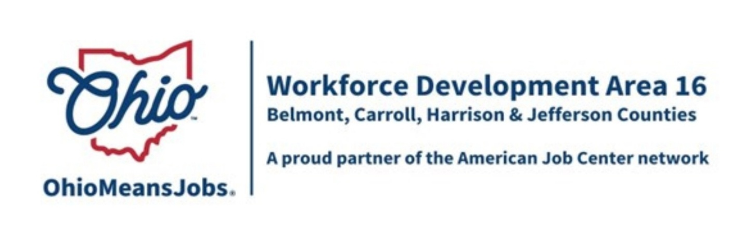

BELMONT COUNTY WDB REPORT: NOVEMBER 2025 – FEBRUARY 2026
3/13/26 WDB MEETING
PROGRAM YEAR 2025 (7/1/25 – 6/30/26)

WIOA/CCMEP PARTICIPANTS AND OMJ REFERRALS

NOVEMBER | CUMULATIVE  PARTICIPANTS | NEW  ENROLLMENTS | TOTAL  PARTICIPANTS | MONTHLY  EXITS | EMPLOYED  AT EXIT | AVERAGE  EXIT WAGE | OMJ  CUSTOMER  REFERRALS
ADULTS | 24 | 2 | 26 | 3 | 3 | $22.00 | XXXXX
DISLOCATED  WORKERS | 4 | 0 | 4 | NA | NA | NA | XXXXX
CCMEP  YOUTH | 72 | 0 | 72 | 3 | 3 | $13.56 | XXXXX
OMJ  CUSTOMERS | XXXXX | XXXXX | XXXXX | XXXXX | XXXXX | XXXXX | NA

DECEMBER | CUMULATIVE  PARTICIPANTS | NEW  ENROLLMENTS | TOTAL  PARTICIPANTS | MONTHLY  EXITS | EMPLOYED  AT EXIT | AVERAGE  EXIT WAGE | OMJ  CUSTOMER  REFERRALS
ADULTS | 26 | 2 | 28 | 2 | 2 | $15.50 | XXXXX
DISLOCATED  WORKERS | 4 | 0 | 4 | 1 | 1 | $21.75 | XXXXX
CCMEP  YOUTH | 72 | 3 | 75 | 4 | 2; 2 lost contact | $13.75 | XXXXX
OMJ  CUSTOMERS | XXXXX | XXXXX | XXXXX | XXXXX | XXXXX | XXXXX | NA

** Referrals = NA; Customers have been seeking UI or employment assistance.

1

JANUARY | CUMULATIVE  PARTICIPANTS | NEW  ENROLLMENTS | TOTAL  PARTICIPANTS | MONTHLY  EXITS | EMPLOYED  AT EXIT | AVERAGE  EXIT WAGE | OMJ  CUSTOMER  REFERRALS
ADULTS | 28 | 5 | 33 | 5 | 3; 2 lost contact | $22.00 | XXXXX
DISLOCATED  WORKERS | 4 | 0 | 4 | 1 | 0; lost contact | NA | XXXXX
CCMEP  YOUTH | 75 | 0 | 75 | 1 | 1 | $11.45 | XXXXX
OMJ  CUSTOMERS | XXXXX | XXXXX | XXXXX | XXXXX | XXXXX | XXXXX | NA

FEBRUARY | CUMULATIVE  PARTICIPANTS | NEW  ENROLLMENTS | TOTAL  PARTICIPANTS | MONTHLY  EXITS | EMPLOYED  AT EXIT | AVERAGE  EXIT WAGE | OMJ  CUSTOMER  REFERRALS
ADULTS | 33 | 3 | 36 | 1 | 1 | $11.00 | XXXXX
DISLOCATED  WORKERS | 4 | 0 | 4 | 2 | 2 | $21.50 | XXXXX
CCMEP  YOUTH | 75 | 2 | 77 | NA | NA | NA | XXXXX
OMJ  CUSTOMERS | XXXXX | XXXXX | XXXXX | XXXXX | XXXXX | XXXXX | NA

GENERAL OMJ OPERATIONS UPDATE

OMJ Traffic

 | NOVEMBER | DECEMBER | JANUARY | FEBRUARY
TOTAL VISITS | 101 | 123 | 130 | 125
TOTAL CLIENTS | 64 | 64 | 77 | 81
NEW CLIENTS | 10 | 14 | 10 | 7
RETURNING CLIENTS | 54 | 50 | 67 | 74
VETERANS | 4 | 4 | 6 | 8

Staff Assistance Provided to Unemployment Insurance Customers

November 27
December 59
January 59
February 49

2
ADULT AND DISLOCATED WORKER SERVICES

Adult

- 12 new enrollments: 7 CDL, 4 STNA, 1 Real Estate.
- Exits = 11; employed = 9.
- Training: 7 CDL; 1 LPN; 1 STNA; 1 computers; 1 phlebotomy.
- Employers: Rebellion Sky, Waste Management, Woodsfield OPCO, We Staff Better, Mack’s Inc., Foster Bridge, Elite Gas Field Services, Recon Oilfield, Longhorn.

Dislocated Worker

- 0 new enrollments.
- Exits = 4; employed = 3.
- Training: 2 CDL; 1 real estate; 1 HVAC.
- Employers: Amazon, H & R block, The Shelly Co.

BUSINESS SERVICES

Rapid Response

- Turf Care in Martins Ferry; 2/24/26 meeting.

The session was led by Sue Bressler, ODJFS Rapid Response coordinator. Mike Schlanz attended.

Per a company representative, Turf Care has approximately 100 total employees, and around 45 were to be laid off.

However, only 6 – 8 employees will lose their jobs due to the following:

- Some left the company for other employment
- Some accepted buyouts/retirement
- Some accepted other positions with the department that isn’t closing.

4 employees attended the Rapid Response session. 3 were from Belmont County and 1 from Wheeling.

- Value City Furniture

- Will be closing around the end of March.
- 13 employees; FT and PT.
- Rapid Response packets were dropped off at the company by Barbara Korba.
- The manager will speak with the employees and get back to us if a meeting is desired.
3
Employer Recruitment at OMJ

- ResCare; 10/8/26

Employer Job Postings

- 90 postings

- Employers: Painters Union, City of Wheeling, Carpenters Union, Wheeling Linen Service, Belmont County, Northwood Health Systems, Sevita. REM Services, K and K Home Builders, Express Employment, Cardinal Health, Welty Home for the Aged, Fox Run, Cafaro/OV Mall, ResCare, Electrical Workers Union, Best One Tire, Trigg Construction, Safelite, Trinity Health System, and Crossmark.

YOUTH/CCMEP SERVICES

- 5 new enrollments.
- Exits = 8; employed = 6; 4 of them graduated from high school; 1 quit GED; 2 still in HS and no longer wanted services; 1 was an out-of-school youth so credential attainment is not relevant.
- Employers: Love’s, Dutch Barn Builders, McKeen Security, Kroger, Auto Zone.

OTHER EVENTS AND INFORMATION

- GRIT Conference (Growing Rural Independence Together
- Staff attended a conference in Marietta on 2/26 and 2/27.
- GRIT provides career assessment, coaching and training services to youth and adults.
- GRIT is a funding source in addition to WIOA and CCMEP.

- 2026 Ohio Valley Job Fair
- May 7th; 10 AM – 1 PM
- Ohio Valley Mall
- ohiomeansjobs.com/Belmont … click on the job fair page.
- 57 registrations received as of March 2nd >>> 48 employers, 4 agencies and 5 training providers.

4

