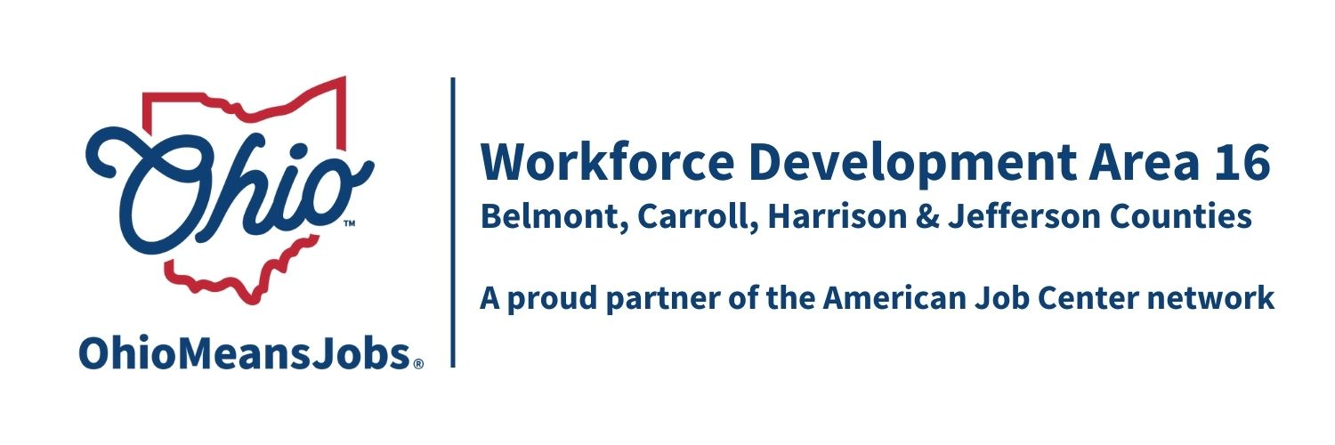
Workforce Development Area16
Report to the Board

Carroll County March 13th, 2026
Nov 2025 | Cumulative  Participants | New Participants  Enrolled | Total  Participants | Exits Per Month | Employed At Exit Per Month | Average Wage At Exit Per Month
Adults | 3 | 1 | 4 | 0 | - | -
Dislocated | 0 | 0 | 0 | 0 | - | -
CCMEP | 13 | 0 | 13 | 0 | - | -
Grit | 2 | 1 | 3 | 0 | - | -
Totals | 18 | 2 | 20 | 0 | - | -

Dec 2025 | Cumulative  Participants | New Participants  Enrolled | Total  Participants | Exits Per Month | Employed At Exit Per Month | Average Wage At Exit Per Month
Adults | 4 | 1 | 5 | 0 | - | -
Dislocated | 0 | 0 | 0 | 0 | - | -
CCMEP | 13 | 0 | 13 | 2 | 2 | $13.75
Grit | 3 | 0 | 3 | 0 | - | -
Totals | 20 | 1 | 21 | 2 | 2 | $13.75

Jan 2026 | Cumulative  Participants | New Participants  Enrolled | Total  Participants | Exits Per Month | Employed At Exit Per Month | Average Wage At Exit Per Month
Adults | 5 | 0 | 5 | 0 | - | -
Dislocated | 0 | 0 | 0 | 0 | - | -
CCMEP | 11 | 0 | 11 | 0 | - | -
Grit | 3 | 0 | 3 | 0 | - | -
Totals | 19 | 0 | 19 | 0 | - | -

General OMJ Operations Update
- OMJ traffic is averaging 100 visitors per month. Most visits have been job seekers requesting resume assistance and updates along with information on current job openings in the area.
- We experienced an increase in UI related traffic in January; however, numbers are expected to decrease with seasonal weather changes. Approximately 15 staff hours per month are dedicated to assisting Unemployment customers in the resource room.
- Visitor counts have been impacted by the lack of a GED Instructor; however, an instructor has been secured, and services are expected to resume regularly soon.
- Relocation Update: Internet installation is complete, and the Commissioners are awaiting the Certificate of Occupancy. An open house will be scheduled, and we anticipate moving into the Moody Avenue location by early April.

Adult and Dislocated Worker Services
- 2 new adult enrollments.
  - 1 pursuing Medical Coding certification and 1 pursuing Medical Billing Certification.
- 1 new GRIT participant enrolled for CDL training.
- Staff continue to support training coordination, monitoring progress, and connecting participants to supportive services.

Business Services
Employer Job Postings

- Noramco – Line Operator
- Cleveland Clinic - Clinical Speech Pathologist Fellow
- CRH – Concrete Ready Mix Truck Driver
- Advance – Store Driver
- Dollar general – Sales Associate
- EOG Resources – Senior Operations Assistant
- Precision Castparts Corp – Inventory Control Specialist
- The Davey Tree Expert – Line Clearance Ground person
- PNC – Part Time Teller
- NAPA – Warehouse Associate
- Tractor Supply – Team Member
- Home Instead – Caregiver
- Subway – Team member
- Dunkin – Team Member
- Candlewood Suites – Guest Service Agent
- Streamline Excavating & Supply – Administrative Assistant
- TriCorps – Security Guard

Youth/CCMEP Services
- No new enrollments.
- 2 CCMEP participants exited to employment, earning an average of $13.75 per hour.
- 11 ongoing youth remain active in Career Exploration, Leadership development, Financial Literacy and Paid work experience.
  - 1 participant is co-enrolled in GRIT
Career & Leadership Activities
- The CCMEP Case Manager visited Conotton Valley Schools monthly to provide career exploration through virtual reality (VR) technology, allowing students to experience occupations in welding, healthcare, manufacturing, public safety, and more.
- Carrollton High School has been added to the list of schools utilizing the VR headset monthly, expanding career exploration outreach and strengthening recruitment efforts for CCMEP services.

Other Events and Information
- In December, staff participated in the Real Money Real World financial literacy simulation at Carrollton High School, assisting students with budgeting and real-world financial decision-making as part of their finance curriculum.
- Staff attended the Work Ohio kickoff meeting in Caldwell in early February. This initiative provides another referral avenue to connect individuals to OMJ services, including career assessments, interest exploration, and job/career coaching support.
- Staff will be attending the GRIT Conference in Marietta in late February to support continued program alignment and workforce development best practices across the region.

