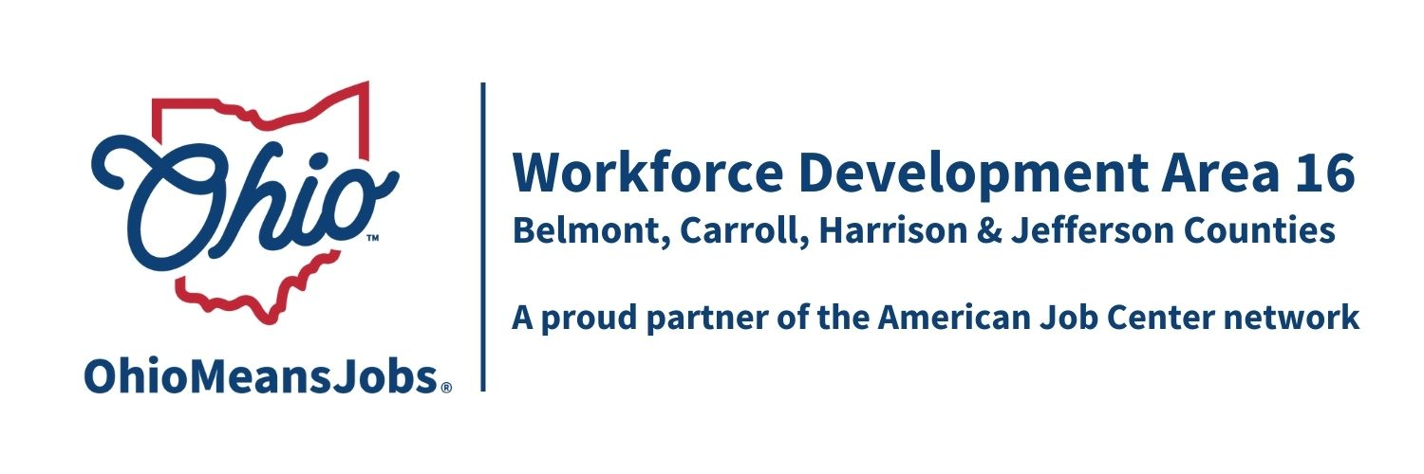
Workforce Development Area16
Report to the Board

Program Year 2025 (7/1/25-6/30/26)
Harrison County
March 2nd , 2026

WIOA/CCMEP Participants and OMJ Referrals

February | Cumulative  Participants | New  Enrollments | Total  Participants | Monthly  Exits | Employed  At  Exit | Average  Exit  Wage | OMJ  Customer  Referrals
Adults | 4 | 3 | 4 | 0 | 0 | N/A | N/A
Dislocated  Workers | 0 | 0 | 0 | 0 | N/A | N/A | N/A
CCMEP  Youth | 11 | 0 | 10 | 1 | 1 | $20 | N/A
OMJ  Customers | N/A | N/A | N/A | N/A | N/A | N/A | N/A

General OMJ Operations Update

Traffic is still steady, with no major issues to report.

OMJ Traffic:
8 Total Visits
2 OWF/Snap E/T
4 Adult
2 miscellaneous

Adult and Dislocated Worker Services

Adult:

3 came in for CDL training
1 finished with her Phlebotomy certification, currently working at Walmart. Working on finding placement for Phlebotomy.

No current Dislocated workers.

Business Services
Employer Job Postings:

Rose Flooring LLC (Local) is looking for an apprentice. It starts at $16 an hour and is based in Harrison County.

Youth/CCMEP Services

10 currently enrolled in the program.
4 kids currently working at various job sites within the county.
1 kid currently enrolled at Belmont college for nursing.
2 kids on program remain on program, however they both accepted Job offers. Offering supportive services till they graduate
1 In college at Ohio University
2 currently focusing on school and anticipating working in the summer
1 Exited to Military

Other Events and Information

No other events currently.

