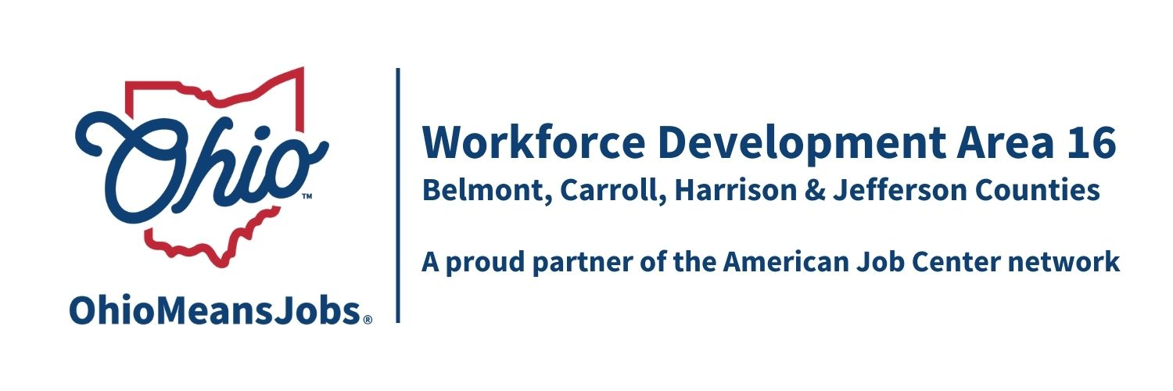
Q and A from WDA16 Youth Services RFP
4/6/26

Question 1: If we bid on 2 separate youth services/elements, do we have to do a separate application for each?
Answer: Yes, each element or service requires a separate application, including I dividual budgets for each service/element. There are some elements in your proposal you only need to submit once for your organization or agency, like your recent audit summary. Other one-time submissions are detailed in the RFP.
End of Questions

