-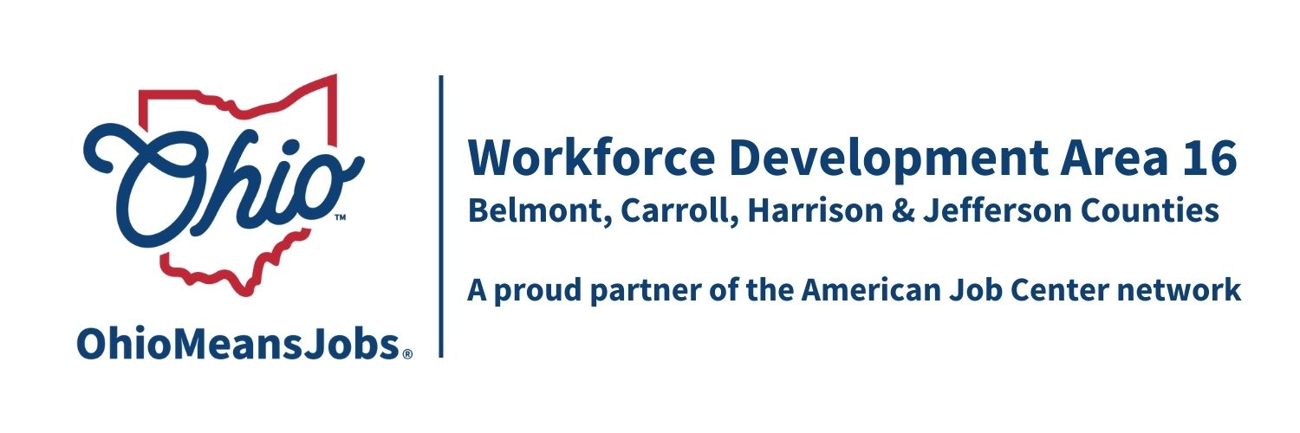
WDB16 Board Meeting
6/5/26
10:00 AM
Puskarich Public Library, Cadiz OH

- Call to Order

- Roll Call

- Approval of Minutes (3/13/26)

- Financial/Participants Reports (Rob and Rebecca)
- Financial Report (May 2026)
- Allocation vs Expense Report
Transfers: Harrison A/DW to Jefferson $______
Jefferson Youth to Harrison $______

Billes to Pay: CORSA $3,842.00
Ohio Workforce Association (OWA) Not to exceed $7,000

- WIOA Update: Staff Report
- WIOA Reauthorization
- ARC ARISE Apprenticeship update
- Area 16 WIOA Performance Standards Negotiations
- AI Eligibility and Tracking Project Special Grant update ($175,0000 awarded!)

- OMJ Operator Reports

- Library MOUs 2026-2028 Approval of the following Library MOU (COG approved 08-2026):
- Harrison Co: Puskarich Public Library System

- Contracts to Approve:
All are “not to exceed” amounts pending administrative negotiations and contracts.

Item # | Agreement | Vendor | Contract Amount
1 | MOU 7/1/26-6/30/27 |  | As per MOU
2 | Outreach Contract  Yr 1 of 4  7/1/26-6/30/27 | OMJ Operators and WDB16 Executive Board recommend not to award an outreach contract this year | Not recommended to award an Area 16 Outreach contract this year
4 | Operator Contract  Year 3 of 4 7/1/26-6/30/27 | Belmont JFS Consortium | As per MOU
5 | AD and DW Framework and Design  Yr 1 of 4 7/1/26-6/30/26 | Jefferson Co CAC | $923,101  (Includes $654,000 for direct participant training and support services)
15 | Belmont Work Experience Youth  Year 1 of 4 7/1/26-6/30/27 | CAC of Belmont Co | $281,800  $29,208 WIOA
16 | Belmont Leadership Devel  Year 1 of 4 7/1/26-6/30/27 | CAC of Belmont Co | $60,618  $6,062 WIOA
17 | Belmont Adult Mentoring  Year 1 of 4 7/1/26-6/30/27 | CAC of Belmont Co  $60,618  $6,062 WIOA | Not recommended for award
18 | Belmont Adult Mentoring  2 Career Navigators  Year 1 of 4 7/1/26-6/30/27 | East Central Ohio ESC | $188,443  $18,844 WIOA
20 | Carroll Work Experience  Year 1 of 4 7/1/26-6/30/27 | Goodwill GC-ECO Inc. | See total below  $123,716
21 | Leadership  Year 1 of 4 7/1/26-6/30/27 | Goodwill GC-ECO Inc. | See total below  $ 30,603
22 | Financial Literacy  Year 1 of 4 7/1/26-6/30/27 | Goodwill GC-ECO Inc. | See total below  $ 30,603
 | Total for 3 services | Goodwill GC-ECO Inc. | $184,922  $56,333 WIOA
23 | Harrison Work Experience  Year 1 of 4 7/1/26-6/30/27 | Jefferson Co CAC Inc. | $185,000  $48,425WIOA
26 | Jefferson Work Experience  Year 1 of 4 7/1/25-6/30/26 | Jefferson Co CAC Inc. | $515,081  $206,032 WIOA
27 | Jefferson Leadership Devel.  Year 4 of 4 7/1/25-6/30/26 | Jefferson Co CAC Inc. | $21,000  $10,500 WIOA
 | Jefferson Co Youth Design and Framework  Year 1 of 4 7/1/26-6/30/37 | Jefferson Co CAC Inc. | $297,673  Not including Work Exp or Leadership
39 | RESEA Area Service Contract  7/1/26-6/30/27 | Jefferson Co. CAC Inc. | RESEA allocation to the area, not to exceed $85,000 until State issues new allocations

- Staff to the Board Contract
Approve _____________________________________________ for year 1 of 4 years for $_________ per year, to provide Staff to the Board services to WDB16.

- AI Special Project Contract with Rob Guentter, RFG Associates Inc.
Approve $7,200.00 of AI Special Project budgeted funds for RFG Associates to provide up to 80 hours of technical support and guidance to the AI Intake and case management project.

- Personal Identifiable Information (PII) Policy

- Other Business

- Next Meetings –Fri 9/11/26 10am TBD
12/4/26 TBD

- Adjournment

