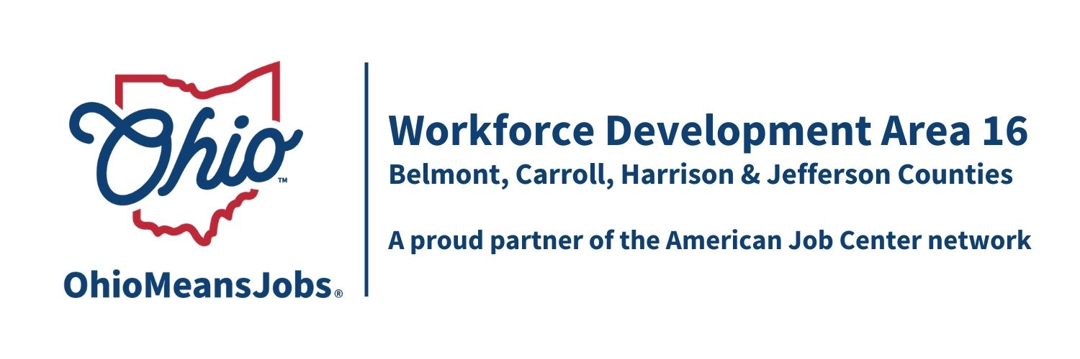
COG Meeting Friday June 12, 2026 10:00 AM
In person at the Harrison Co JSF Office, 520 N Main Street Cadiz, OH

- Call to Order

- Roll Call

- Approval of Minutes (3/20/26)

- Financial/Participants Reports (Rob and Rebecca)
- Financial Report (April 2026)
- Allocation vs Expense Report

Transfers: Harrison A/DW to Jefferson $40,000
Jefferson Youth to Harrison $40,000

Bills to Pay: CORSA $3,842.00
Ohio Workforce Association (OWA) Not to exceed $5,040
(Fiscal report and related items recommended for approval by WDB16 10-2026)

- WIOA Update: Staff Report
- WIOA Reauthorization
- ARC ARISE Apprenticeship update
- Area 16 WIOA Performance Standards Negotiations
- AI Eligibility and Tracking Project Special Grant update ($175,0000 awarded!)

- OMJ Operator Report

- Use of Personal Identifiable Information Policy
(Recommended for approval by WDB16 19-2026)

- Contracts to Approve:
All are “not to exceed” amounts pending administrative negotiations and contracts.

Item # | Agreement | Vendor | Contract Amount
1 | MOU 7/1/26-6/30/27 |  | As per MOU
Recommended WDB16
12-2026
2 | Outreach Contract  Yr 1 of 4  7/1/26-6/30/27 | OMJ Operators and WDB16 Executive Board recommend not to award an outreach contract this year | Not recommended to award an Area 16 Outreach contract this year
4 | Operator Contract  Year 3 of 4 7/1/26-6/30/27 | Belmont JFS Consortium | As per MOU
Recommended WDB16
13-2026
5 | AD and DW Framework and Design  Yr 1 of 4 7/1/26-6/30/27 | Jefferson Co CAC | $923,101  (Includes $654,000 for direct participant training and support services)
Recommended WDB16
14-2026
15 | Belmont Work Experience Youth  Year 1 of 4 7/1/26-6/30/27 | CAC of Belmont Co | $281,800  $29,208 WIOA
16 | Belmont Leadership Devel  Year 1 of 4 7/1/26-6/30/27 | CAC of Belmont Co | $60,618  $6,062 WIOA
17 | Belmont Adult Mentoring  Year 1 of 4 7/1/26-6/30/27 | CAC of Belmont Co  $60,618  $6,062 WIOA | Not recommended for award
18 | Belmont Adult Mentoring  2 Career Navigators  Year 1 of 4 7/1/26-6/30/27 | East Central Ohio ESC | $188,443  $18,844 WIOA
20 | Carroll Work Experience  Year 1 of 4 7/1/26-6/30/27 | Goodwill GC-ECO Inc. | See total below  $123,716
21 | Leadership  Year 1 of 4 7/1/26-6/30/27 | Goodwill GC-ECO Inc. | See total below  $ 30,603
22 | Financial Literacy  Year 1 of 4 7/1/26-6/30/27 | Goodwill GC-ECO Inc. | See total below  $ 30,603
 | Total for 3 services | Goodwill GC-ECO Inc. | $184,922  $56,333 WIOA
23 | Harrison Work Experience  Year 1 of 4 7/1/26-6/30/27 | Jefferson Co CAC Inc. | $185,000  $48,425WIOA
26 | Jefferson Work Experience  Year 1 of 4 7/1/26-6/30/27 | Jefferson Co CAC Inc. | $515,081  $206,032 WIOA
27 | Jefferson Leadership Devel.  Year 1 of 4 7/1/25-6/30/27 | Jefferson Co CAC Inc. | $21,000  $10,500 WIOA
 | Jefferson Co Youth Design and Framework  Year 1 of 4 7/1/26-6/30/27 | Jefferson Co CAC Inc. | $297,673  Not including Work Exp or Leadership
 |  | Items15-39 above, excluding Item 17, recommended WDB16 15-2026
39 | RESEA Area Service Contract  7/1/26-6/30/27 | Jefferson Co. CAC Inc.  Recommended WDB16  16-2026 | RESEA allocation to the area, not to exceed $85,000 until State issues new allocations

- Staff to the Board Contract
Approve Rebecca F. Safko for year 1 of 4 years (7/1/26 to 6/30/27) for $67,600 per year, to provide Staff to the Board services to WDB16.
(Recommended for approval by WDB16 17-2026)

- AI Special Project Contract with Rob Guentter, RFG Associates Inc.
Approve $7,200.00 of AI Special Project budgeted funds plus documented mileage reimbursement for RFG Associates to provide up to 80 hours of technical support and guidance to the AI Intake and Case Management project. (Recommended for approval by WDB16 18-2026)

- Other Business

- Retirement recognition for Rob Guentter

- Next Meetings – Fri September118, 2026 10am Cadiz
Last meeting of 2026: 12/11/26

- Adjournment

