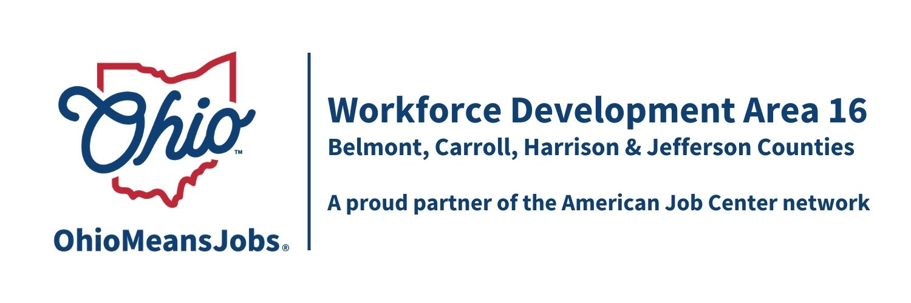
Staff to the Board Report 6/5/26 Rob Guentter AICP

WIOA Reauthorizations: The latest WIOA reauthorization is no news at all. Congress passed a continuing resolution for funding (we get a small increase for WDA16), and a few committees are talking about workforce. There is no consensus to move anything forward currently.

FY2026 WIOA Allocations: Area 16 will be receiving additional adult, dislocated workers, and youth funding next year. These funds are broken into county allocations, and Rebecca has requested specific county breakdowns.
Compared to FY2026 for WDB16 in FY 2027, we will get an additional $184,555 broken down as follows:
Adult +$43,404
Dislocated Worker +$89,039
Youth +$52,112

ARC ARISE Apprenticeship Update: A multi million letter of intent has been submitted to ARC to fund implementation of a tri-state Apprenticeship development and support program. Unfortunately, the project was not invited to submit a full proposal. The project leadership team is looking into other options to fund this important work.
AI Eligibility and Tracking Project Special Grant request: Area 16 has been awarded a $175,000 grant to design and demonstrate a mobile WIOA Adult and Youth project that will allow staff to focus on high value services and improve client experience. Our concept will allow client mobile application, which AI automated eligibility assessment. The system would also guide required monitoring, client interaction, and follow up. Staff would be required to approve all documents and case notes to link automatically to ARIES (state reporting system). Areas 1, 15, 16, and 17 jointly submitted the proposal to be a part of this demonstration project. No local funding, other than staff coordination, would be required. We see this as a viable demonstration effort that could be used statewide. Current meetings with the State are focusing on the process to bid for a vendor and how the state will coordinate/integrate their other ARIES work with this project.

Industry Sector Partnership (ISP) Activity in WDA16: The 4 counties in Area 16 are of the only counties in Ohio without Industry Sector Partnerships (ISPs). We are working to change that! Appalachian Ohio Manufacturers Council (AMOC), based in Marietta, is working to expand services into Belmont Co, and a consortium of WDB16, JobsOhio (OhioSE), OMEGA, and the Mahoning Valley Manufacturing Council (MVMC) are working to create an ISP to serve Jefferson, Carroll, and Harrison Cos. ISPs are business/industry led consortiums that see businesses working collaboratively for common good for things like shared safety training, coordinated purchasing, and apprenticeships. Agencies like OMJs are involved to meet the needs determined by the ISP. Business drives this process, and were they have business champions/leaders, this concept can result in more profitable companies and stronger workforces. This is ongoing work and next steps would include the creation of a 501(c)3, develop a formal ISP Plan, and outreach to area businesses.

Performance Standards: The state will be sending us our “negotiated” WIOA Performance Standards for next year by the end of July. They want the final negotiations done by August 2026. This should not be an issue this cycle.

