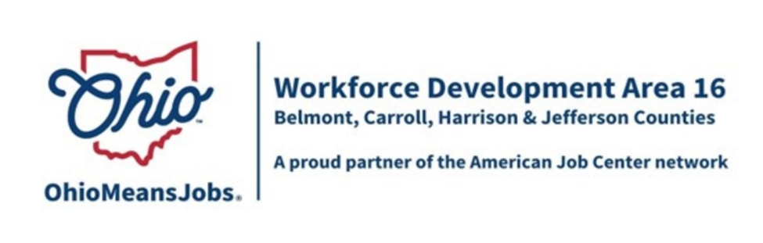

BELMONT COUNTY WDB REPORT: MARCH 2026 AND APRIL 2026
6/5/26 WDB MEETING
PROGRAM YEAR 2025 (7/1/25 – 6/30/26)

WIOA/CCMEP PARTICIPANTS AND OMJ REFERRALS

MARCH | CUMULATIVE  PARTICIPANTS | NEW  ENROLLMENTS | TOTAL  PARTICIPANTS | MONTHLY  EXITS | EMPLOYED  AT EXIT | AVERAGE  EXIT WAGE | OMJ  CUSTOMER  REFERRALS
ADULTS | 36 | 4 | 40 | 6 | 3 | $15.00 | XXXXX
DISLOCATED  WORKERS | 4 | 1 | 5 | 0 | NA | NA | XXXXX
CCMEP  YOUTH | 77 | 1 | 78 | 3 | 0 | NA | XXXXX
OMJ  CUSTOMERS | XXXXX | XXXXX | XXXXX | XXXXX | XXXXX | XXXXX | 4

APRIL | CUMULATIVE  PARTICIPANTS | NEW  ENROLLMENTS | TOTAL  PARTICIPANTS | MONTHLY  EXITS | EMPLOYED  AT EXIT | AVERAGE  EXIT WAGE | OMJ  CUSTOMER  REFERRALS
ADULTS | 40 | 4 | 44 | 1 | 0 | NA | XXXXX
DISLOCATED  WORKERS | 5 | 0 | 5 | 0 | NA | NA | XXXXX
CCMEP  YOUTH | 78 | 6 | 84 | 0 | NA | NA | XXXXX
OMJ  CUSTOMERS | XXXXX | XXXXX | XXXXX | XXXXX | XXXXX | XXXXX | 1

1
GENERAL OMJ OPERATIONS UPDATE

OMJ Traffic

 | MARCH | APRIL
TOTAL VISITS | 144 | 138
TOTAL CLIENTS | 89 | 75
NEW CLIENTS | 11 | 18
RETURNING CLIENTS | 78 | 57
VETERANS | 4 | 10

Staff Assistance provided to unemployment Insurance Customers

March 32

April 16

ADULT AND DISLOCATED WORKER SERVICES

Adult
- New enrollments = 8
- Training program: 6 CDL and 2 phlebotomy.
- Exits = 6
- Credential: 4(computer networking, phlebotomy, STNA, CDL); 1 quit medical assisting and 1 quit CDL.
- Employers: Panera Bread, Hampton Inn, Recon Oilfield

Dislocated Worker
- New enrollments = 1
- Training program: CDL
- Exits = 0

YOUTH/CCMEP SERVICES

- New enrollments = 7.
- Exits = 3; 1 obtained GED; 1 graduated HS; 1 is home-schooled; lost contact with all three.

2
BUSINESS SERVICES

Employer Recruitments at OMJ

- Jennmar Services: coal mining positions

- ResCare: direct care positions

Employer Job Postings

- Postings = 44

- Rig Management, ODOT, Noramco, Belmont County JFS, William Charles Construction, Randall Gallagher Memorials, Cardinal Health, Halliburton, Belco Works, Belmont Carson Petroleum, Village of Powhatan, Peterson Rehabilitation and Healthcare, Jennmar Services.

OTHER EVENTS AND INFORMATION

Ohio Valley Job Fair
- May 7th, 10 -1, Ohio Valley Mall
- 116 vendors
- 102 employers
- 7 agencies
- 7 training providers
- All vendor surveys were very positive.
- Hire feedback to date:
- Oglebay Park
- Fox Run Center for Children
- Youth Services System
- Whiteside Chevrolet – GMC
- Ferguson’s House of Furniture

GRIT

- Enrolled 1 adult in CDL and 1 youth in CCMEP.

3

