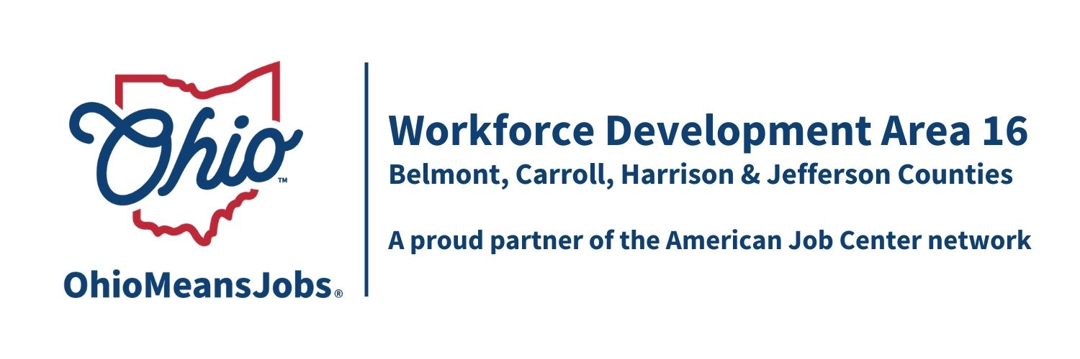
AREA 16 Council of Government (COG)
Meeting Minutes
March 20, 2026
Harrison Co DJFS, 520 N. Main Street, Cadiz OH

Present: Michelle Santin (JFS Director) representing Tony Morelli, Commissioner (Jefferson Co.), Chris Modranski, Commissioner (Carroll Co.), Dustin Corder, Commissioner (Harrison Co.), and Jerry Echemann, Commissioner (Belmont Co.).

Visitors: Rebecca Safko, Mike Schlanz, Hope McAfee, Deb Knight, Jennifer Burns, Jacob Barr, and Rich Gualtiere

- Call to Order and Roll Call:
Meeting called to order by Chair Chris Modranski at 10:06 am.
A quorum of COG members was present to conduct business.

- Approval of Minutes:
Motion 1-2026 to approve September 26, 2025, COG Minutes as written and waive the December 19, 2025 meeting that was cancelled due to power outage.
1st-Echemann 2ndSantin Motion Carried

- Financial/Participant Reports and Transfers (Rebecca):
Rebecca provided the financial report based on the January 2026 statement.
All expenditures are in line for this time of the year, although administrative dollars are getting very tight. She also shared that the annual Audit went very well and the final report will be released soon with no audit findings for the area. She thanks all of the staff for another great year.
Transfers: None
Accept: $21,000 of RESEA funding though 6/30/26 and modify JCCAC RESEA contract to reflect this increase.
(These actions were recommended by the WDB16 Motion 2-2026)
Motion 2-2026 Motion to approve financial report, receipt of RESEA funding and modification of JCCAC RESEA contract.
1st -Corder 2nd- Echemann Motion Carried

- WIOA Update: Staff Report (Rob)
Rob was unable to attend, but provided a written report on the following topics:

WIOA Update: Staff Report
- WIOA Reauthorization
- WDB16 2-year Board appointments/recertification-Approved
- OMJ Center Recertifications-All 4 counties OMJs recertified
- ARC ARISE Apprenticeship update
- 4-year Youth Elements Assessment
- AI Eligibility and Tracking Project Special Grant update
- Industry Sector Partnership (ISP) Activity in WDA16

- County Reports

Belmont Co: Mike Schlanz reviewed the Belmont Co data handout report. OMJ traffic was 130 in Jan and 123 in Feb. Rapid Response worked with Turf Care and Value City Furniture, both who announced layoffs. Mike highlighted the upcoming May 7, 2026, Ohio Valley Job Fair (10am-1pm at the Ohio Valley Mall). Currently 70 employers and agencies are registered, and the final count usually exceeds 100.

Carroll Co: Jennifer Burns gave an overview of the OMJ, including that over 100 clients visit the center monthly. They have been tracking that about 15 hours per month of staff time is devoted to unemployment issues. Additionally, 17 businesses are currently using the OMJ for job search. The new OMJ Center at the Carroll Co Anex Building (211 Moody Ave SW Carrollton OH) hosted a ribbon cutting and open house on March 19, 2026.

Harrison Co: Jacob Barr shared the Harrison Co OMJ data report. They will be supporting a social service outreach event April 25, 2026, likely at Sally Buffalo Park. Jacob discussed a flooring installation apprenticeship.

Jefferson Co: Hope McAfee discussed their submitted written report. They are catching up with their adult and dislocated waiting lists and the youth CCMEP waiting list is caught up. Hope has started working on their August Job Fair and is excited to do it again at Steubenville HS (Big Red). She is participating in an online GRIT Q and A on April 13 and has agreed to be a panelist at the SE Ohio Workforce Summit in Marietta on April 16. As our area RESEA vendor, they are setting up meetings with the other 3 counties to improve understanding and coordination to benefit our RESEA recipients. They are also working on scheduling a Partners meeting.

- OMJ Recertification: All 4 OMJ Centers have been recertified by ODJFS. Carryover action that was on the 12/19/25 agenda.

Motion 03-2026 Motion to Approve the Recertification Committee recommendation to approve the recertification of all 4 WDA16 OhioMeansJobs (OMJ) Centers
(Approved by WDB16 Motion 24-2025)
1st - Echemann 2nd- Corder Motion Carried

- ARC-ARISE Apprenticeship Implementation Grant: Carryover action that was on the 12/19/25 agenda.

Motion 04-2026 Motion to Approve the partnership grant submission to ARC-ARISE for an Apprenticeship Implementation Grant and pledging up to $50,000 of in-kind per year match from existing WDA16 programs including staff time, navigator time, and other CCMEP youth activities. (Approved by WDB16 Motion 25-2025)
1st -Corder 2nd- Echemann Motion Carried

- Special Grant Request for AI Eligibility and Tracking project: Carryover action that was on the 12/19/25 agenda.

Motion 05-2026 to Request a $175,000 Special Project grant from ODJFS to design and demonstrate an AI driven intake, eligibility determination, and monitoring /tracking program for Adult and Dislocated Worker clients (Approved by WDB16 Motion 26-2025 1st Echemann 2nd- Corder Motion Carried

- Professional Development for WDB16 Board members: Rebecca noted the upcoming SE Ohio Workforce Summit in Marietta on April 16, 2026, that will feature Board Orientation and Engagement sessions. This motion will provide funds for Board members to attend, covering the $75.00/per person registration and milage for this 1-day event. Rebecca shared that Rob encourages the Board to fund ongoing professional development for the Board in the future. al

Motion 06-2026 to provide up to $2,000 WIOA funding for board member professional development to 6/30/26. 1st Corder 2nd- Echemann Motion Carried

- ARC-ARISE Apprenticeship Implementation Grant: Rebecca explained that a grant writer has been secured by the project fiscal agent in PA for the project and that 10 workforce areas (PA, WV, and Ohio) have each been asked to contribute $1,000 for this service to prepare and submit a full ARC-ARISE application. A letter of intent has already been submitted, and we are waiting for ARC to “invite” a full application.

Motion 07-2026 Motion to approve providing up to $1,000 for the grant preparation of the ARC-ARISE Apprenticeship Implementation grant. 1st Echemann 2nd- Corder Motion Carried

- Library MOUs: Every 2 years the OMJs are required to enter a Memorandum of Understanding (MOU) with at least one (1) library in their county. This process helps build partnerships and extends OMJ services/outreach to other parts of each county. A few more MOUs will be coming in for our June 2026 meeting. Commissioner Corder inquired into the status of Harrison

Motion 08-2026 to approve the following Library MOUs from 7/1/26 to 6/30/28:
- Belmont Co: Bellaire Public Library, Belmont Co District Library, Barnesville Hutton Memorial Library
- Carroll Co: Carroll Co Library District
- Jefferson Co: Public Library of Steubenville and Jefferson Co
1st Echemann 2nd- Corder

Discussion: Commissioner Corder inquired into the status of Harrison’s. Jacob responded that it was almost done. Clarification that this was just collaborative and no funds were exchanged.

Amended Motion 08-2026 to include acceptance of Harrison Library MOU when completed
1st Echemann 2nd- Corder Motion Carried

- RFP and RFQ Approval to Bid: Rebecca requested that all people attending this meeting, who may potentially be bidders on any of this work, to exit the meeting. Rich and Hope left. Rebecca then went over all RFP/RFQs except the Staff to the Board RFP in general and indicated all will be advertised as required. There were no questions and Rebecca turned the meeting over to Mike Schlanz. Rebecca left the meeting.
Mike then went over the Staff to the Board RFP, then called Rebecca, Rich and Hope back into meeting.

Motion 09-2026 to approve the bidding of the following RFPs or RFQ:
- Youth Elements RFP (all 4 WDA16 counties) as per each County assessment
effective 7/1/26-6/30/30
- Outreach RFQ ($ 10,000 to $40,000 recommended) effective 7/1/26-6/30/30
- Jefferson Co. Youth Design and Framework RFP effective 7/1/26-6/30/30
- Jefferson Co. Adult and Dislocated Worker Framework and Design RFP
effective 7/1/26-6/30/30
- Staff to the Board RFP services, effective 7/1/26-6/30/30
1st Corder 2nd- Echemann Motion Carried

- 2026 WDB16 Proposed COG Meeting Dates (all Fridays at 10am)
Harrison Co ODJFS Office, Cadiz OH:
- 3/20/26
- 6/12/26
- 9/18/26
- 12/11/26
Motion 10-2026 to approve above dates.
1st Corder 2nd- Echemann Motion Carried

- Open Discussion – None

- Motion to Adjourn
Motion 11-2025 Motion to Adjourn
1st Echemann 2nd- Corder Motion Carried
Adjournment- 10:55am

_________________________________________________ _____________
COG Chair Date

