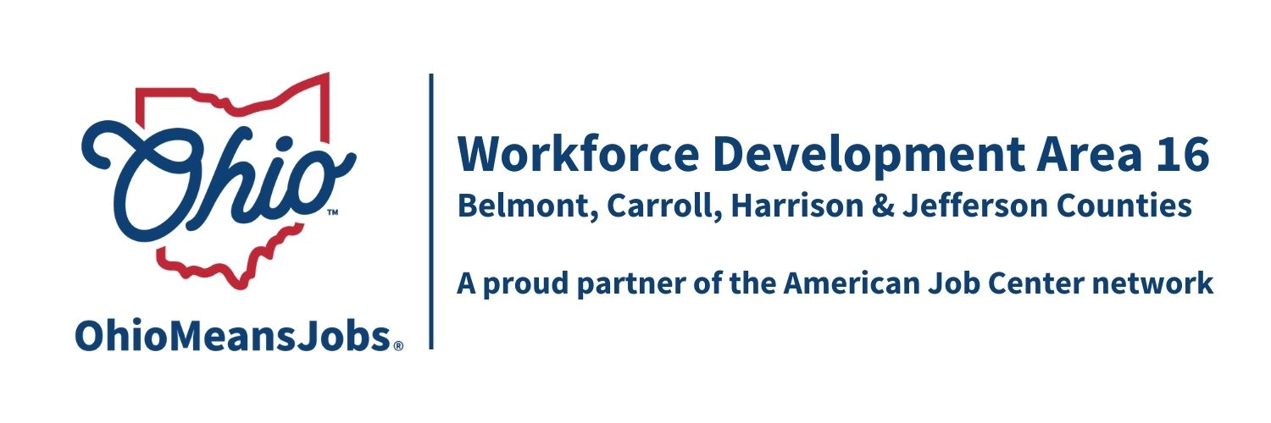
Workforce Development Area16
Report to the Board

Program Year 2025 (7/1/25-6/30/26)
Harrison County
June 5th, 2026

WIOA/CCMEP Participants and OMJ Referrals

February | Cumulative  Participants | New  Enrollments | Total  Participants | Monthly  Exits | Employed  At  Exit | Average  Exit  Wage | OMJ  Customer  Referrals
Adults | 3 | 2 | 5 | 0 | 0 | N/A | N/A
Dislocated  Workers | 0 | 0 | 0 | 0 | N/A | N/A | N/A
CCMEP  Youth | 10 | 1 | 8 | 3 | 1 | $36.15 | N/A
OMJ  Customers | N/A | N/A | N/A | N/A | N/A | N/A | N/A

General OMJ Operations Update

Traffic is still steady, with no major issues to report.

OMJ Traffic:
18 Total Visits
Varied between:
OWF, SNAP E/T, Unemployment, WIOA and Job Searching

Adult and Dislocated Worker Services

Adult:

1 came in for LPN training
1 came in for Rad tech
2 still Job searching
1 Graduated from BBR

No current Dislocated workers.

Business Services
Employer Job Postings:

Hiring event for USPS in May went well!
RESCARE worker for Cadiz office

Youth/CCMEP Services
8 Total Participants
2 Exited due to no longer being eligible
1 Exited to employment at Wheeling Hospital with her RN from Belmont College
5 getting ready for a Work Experience

Other Events and Information

Spotlight:
The CCMEP kid that was exited to employment came on to the program with some college and was a single mother. She was able to graduate college with her Registered Nursing Degree and is not a full-time nurse at Wheeling Hospital. She has been a bright spot in the program!

